**DAY 4 Assignment**

1. GROUP BY with WHERE - Orders by Year and Quarter

Display, order year, quarter, order count, avg freight cost only for those orders where freight cost > 100

SELECT

EXTRACT(YEAR FROM order_date) AS order_year,

EXTRACT(QUARTER FROM order_date) AS order_quarter,

COUNT(*) AS order_count,

AVG(freight) AS avg_freight_cost

FROM

orders

WHERE

freight > 100

GROUP BY

EXTRACT(YEAR FROM order_date),

EXTRACT(QUARTER FROM order_date)

ORDER BY

order_year,

order_quarter;

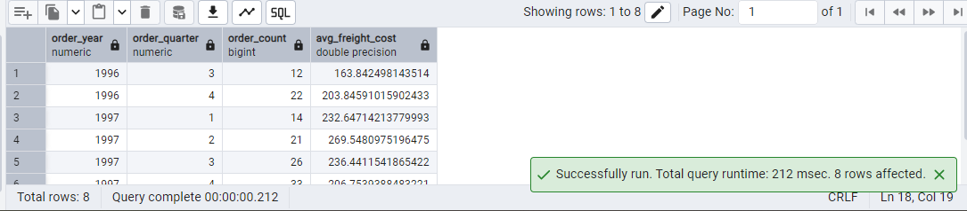

2. GROUP BY with HAVING - High Volume Ship Regions

Display, ship region, no of orders in each region, min and max freight cost  
 Filter regions where no of orders >= 5

SELECT

ship_region,

COUNT(*) AS order_count,

MIN(freight) AS min_freight,

MAX(freight) AS max_freight

FROM

orders

WHERE

ship_region IS NOT NULL

GROUP BY

ship_region

HAVING

COUNT(*) >= 5

ORDER BY

ship_region;

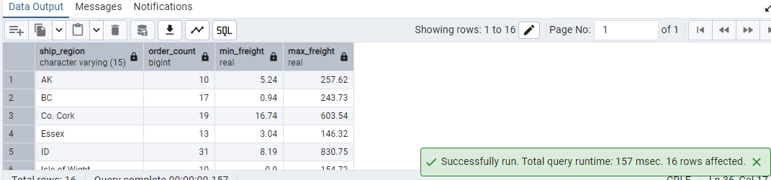

3. Get all title designations across employees and customers ( Try UNION & UNION ALL)

SELECT title AS designation FROM employees

UNION

SELECT contact_title AS designation FROM customers;

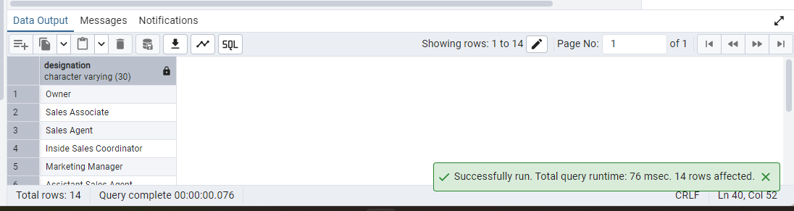

SELECT title AS designation FROM employees

UNION ALL

SELECT contact_title AS designation FROM customers;

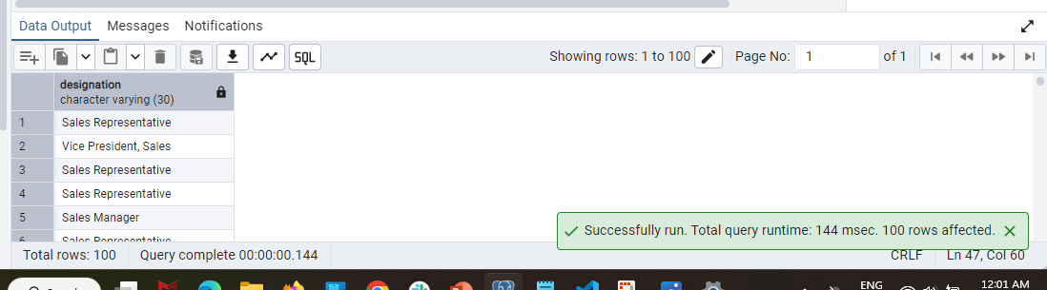

4. Find categories that have both discontinued and in-stock products

(Display category_id, instock means units_in_stock > 0, Intersect)

SELECT category_id

FROM products

WHERE units_in_stock > 0

INTERSECT

-- Categories with discontinued products

SELECT category_id

FROM products

WHERE discontinued = 1;

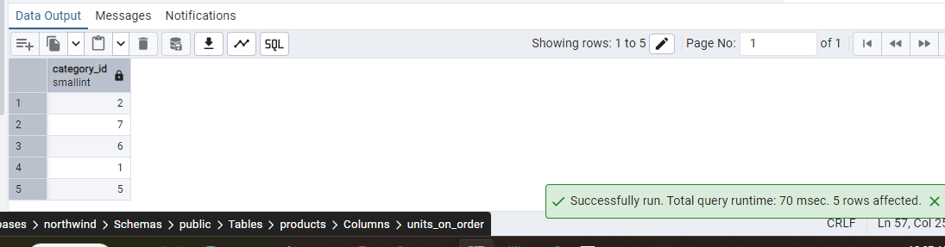

5. Find orders that have no discounted items (Display the order_id, EXCEPT)

SELECT order_id

FROM orders EXCEPT

SELECT order_id

FROM order_details

WHERE discount > 0

